PRESS PHOTOS

Safety devices – Blue Responsibility
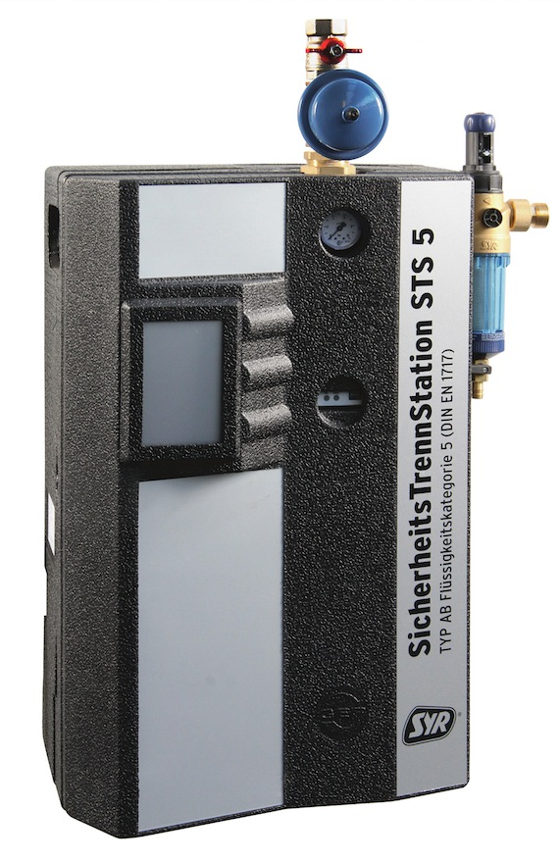 | 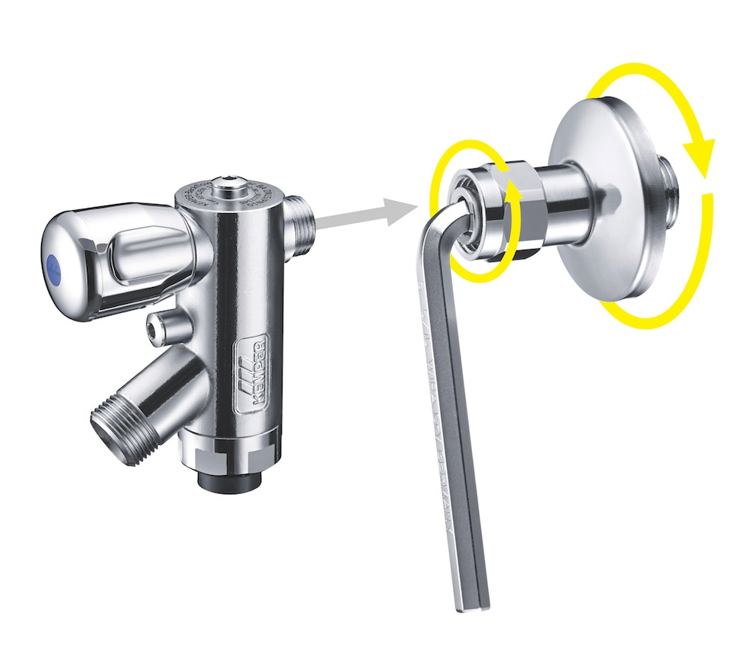
01: The STS 5 safety separator station from SYR is used for category 5 when mechanical safety devices are no longer sufficient.  Source: SYR - Hans Sasserath GmbH & Co. KG | 02: Designed especially for standardised heating protection in living areas, the residential BA system separator also looks good in bathrooms or kitchens and even fits into tight spaces thanks to the clever wall screw-fitting.  Source: Gebr. Kemper GmbH + Co. KG
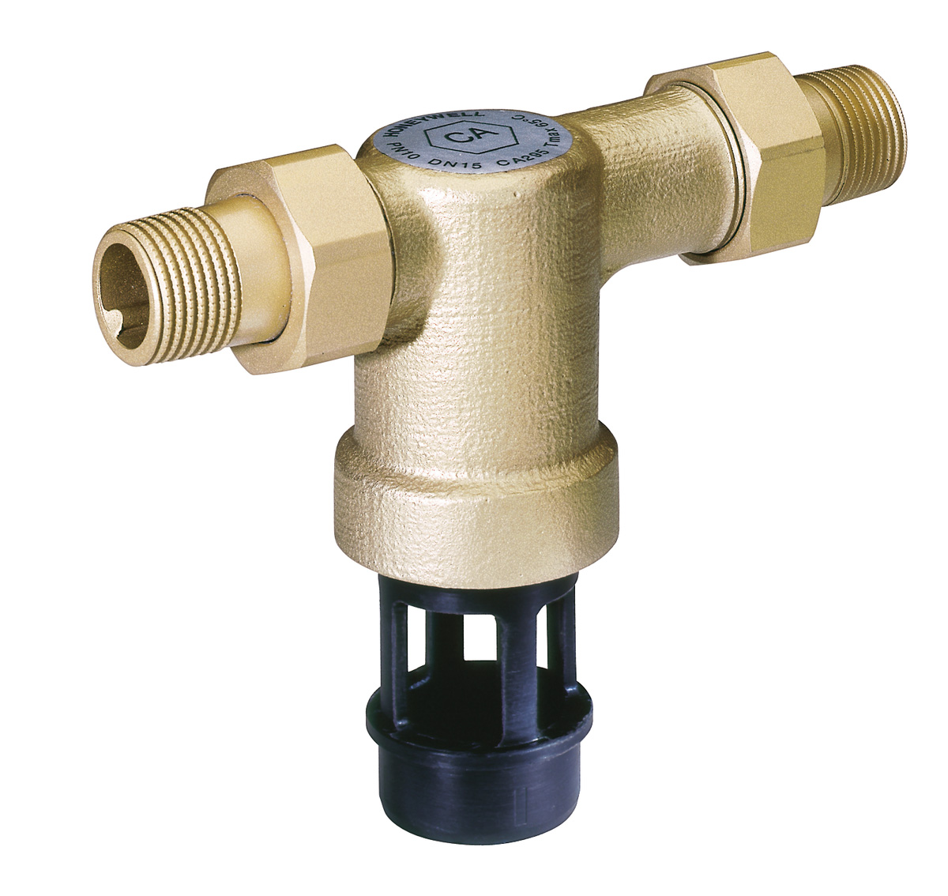 | 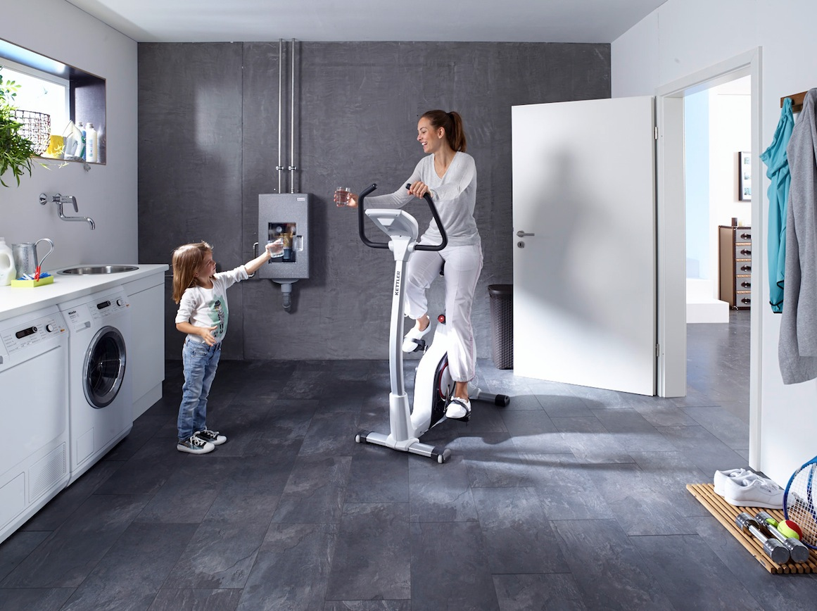
03: The CA295 system separator from Honeywell is suitable for protecting drinking water systems against backpressure, backflow and return suction. It protects against liquids up to and including liquid category 3.  Source: Honeywell GmbH – Haustechnik | 04: Safety devices make a substantial contribution to maintaining drinking water hygiene.  Source: Honeywell GmbH – Haustechnik

Press contact:
Blue Responsibility
c/o Public Affairs PR Agentur GmbH
Kirsten Vogt / Antje Frommfeld
Kamekestr. 21, 50672 Cologne
Germany
Tel.: +49 221 951441-911 /-913
kirsten.vogt@public-affairs.de /
antje.frommfeld@public-affairs.de

