PRESS PHOTOS

The path of water – Blue Responsibility
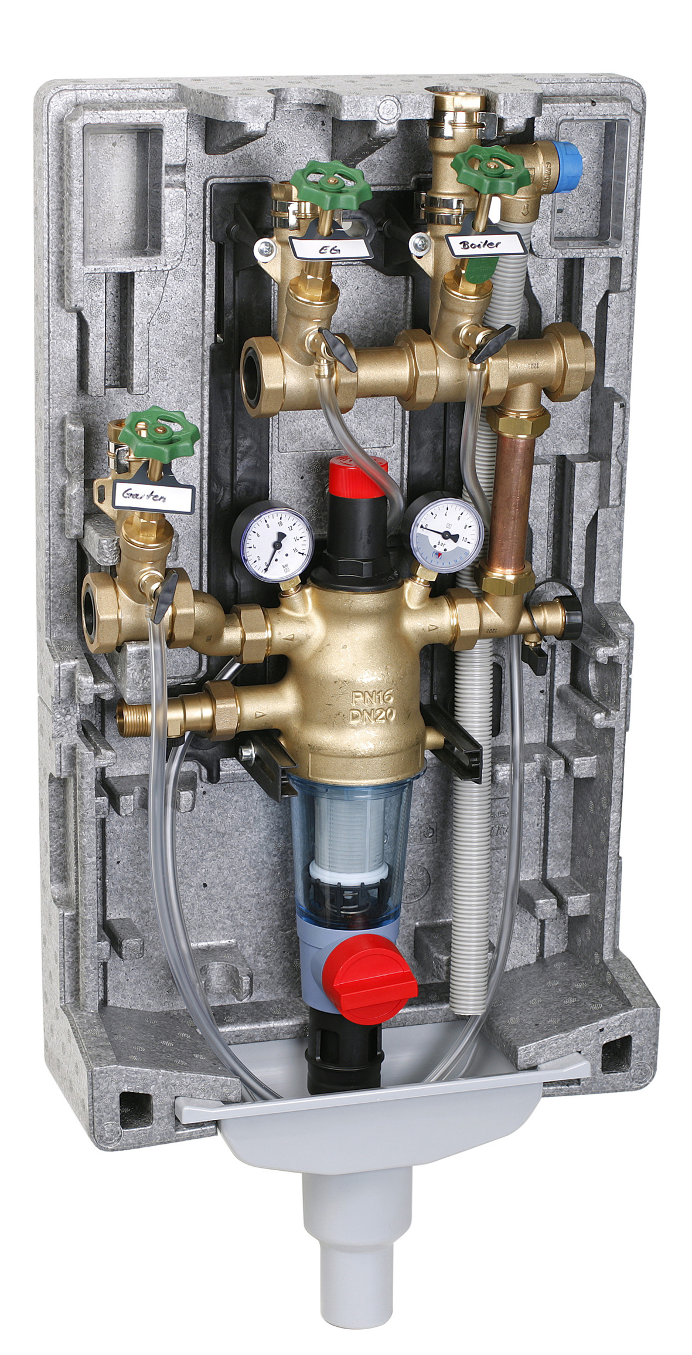 | 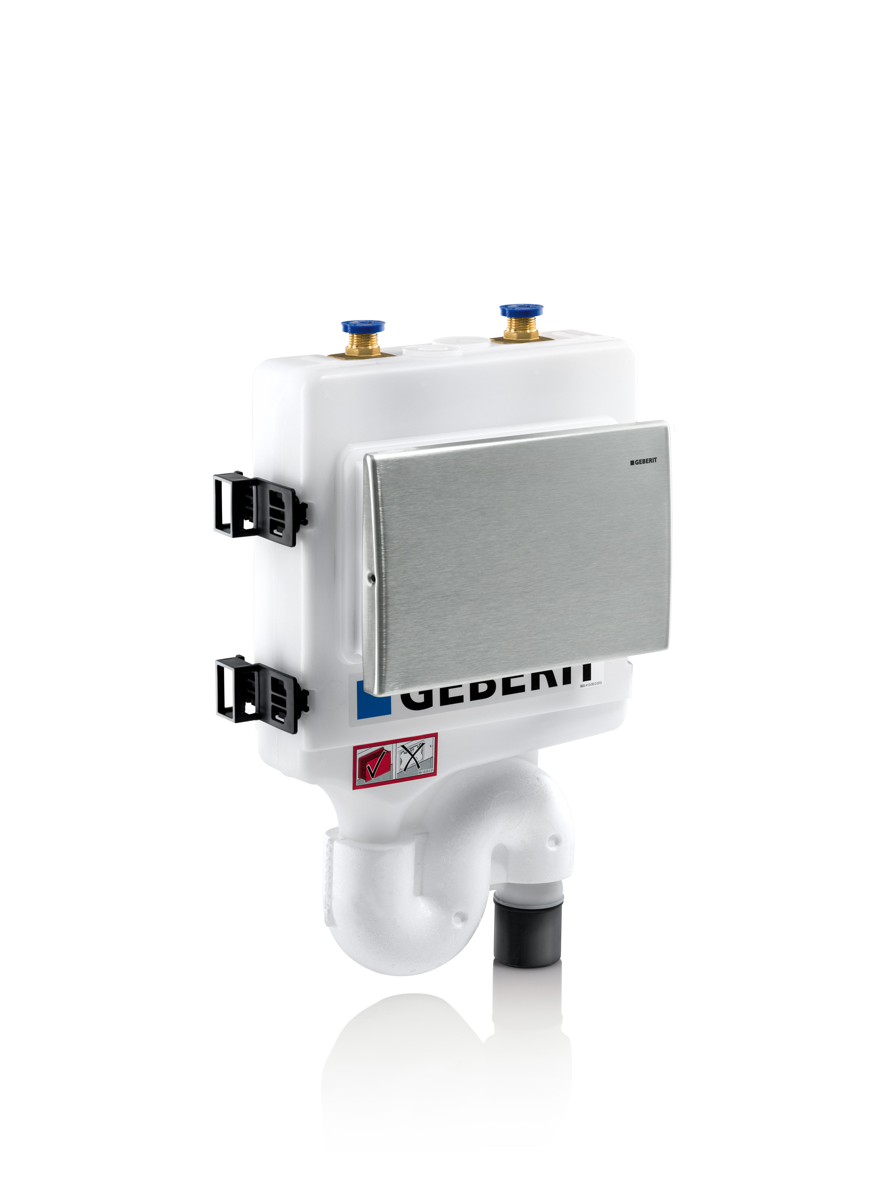
01: The PrimusCenter from Honeywell offers a functional and compact product for the area of drinking water hygiene which unites all elements of domestic plumbing.  Source: Honeywell GmbH – Haustechnik | 02: The Geberit hygiene flushing system provides regular water exchange and monitors the temperature in cold water pipes.  Source: Geberit Vertriebs GmbH
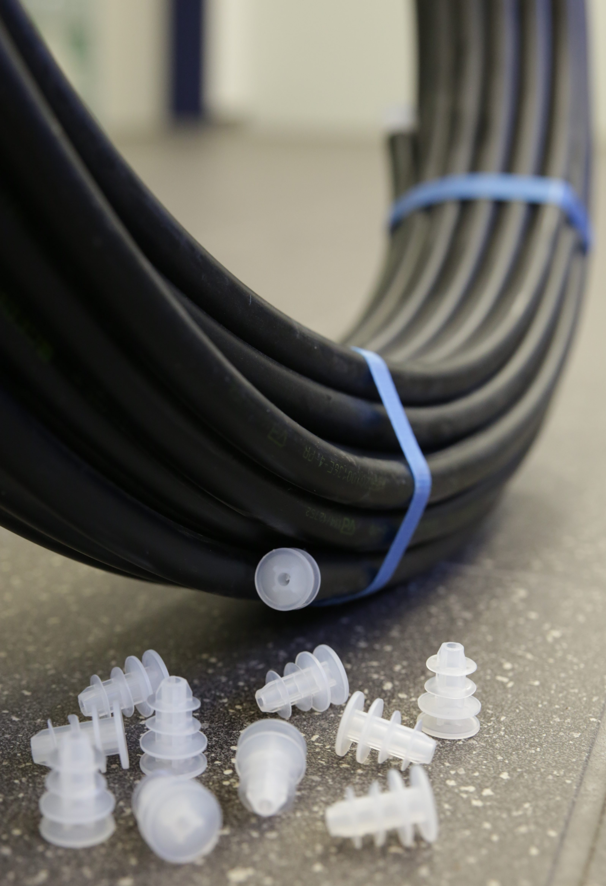 | 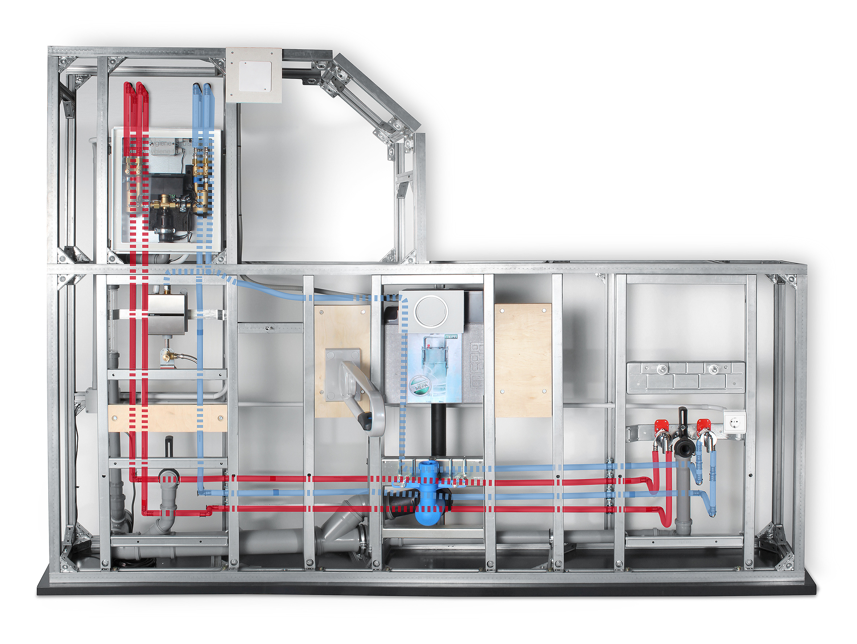
03: Geberit closes the ends of its Mepla composite pipes immediately after production and also offers replacement bungs.  Source: Geberit Vertriebs GmbH | 04: The hygiene flushing stations from Mepa can be comfortably integrated into the “VariVIT” pre-wall installation system. Installation in stud partition walls, other pre-wall systems or brick walls is also possible.  Source: Mepa – Pauli und Menden GmbH

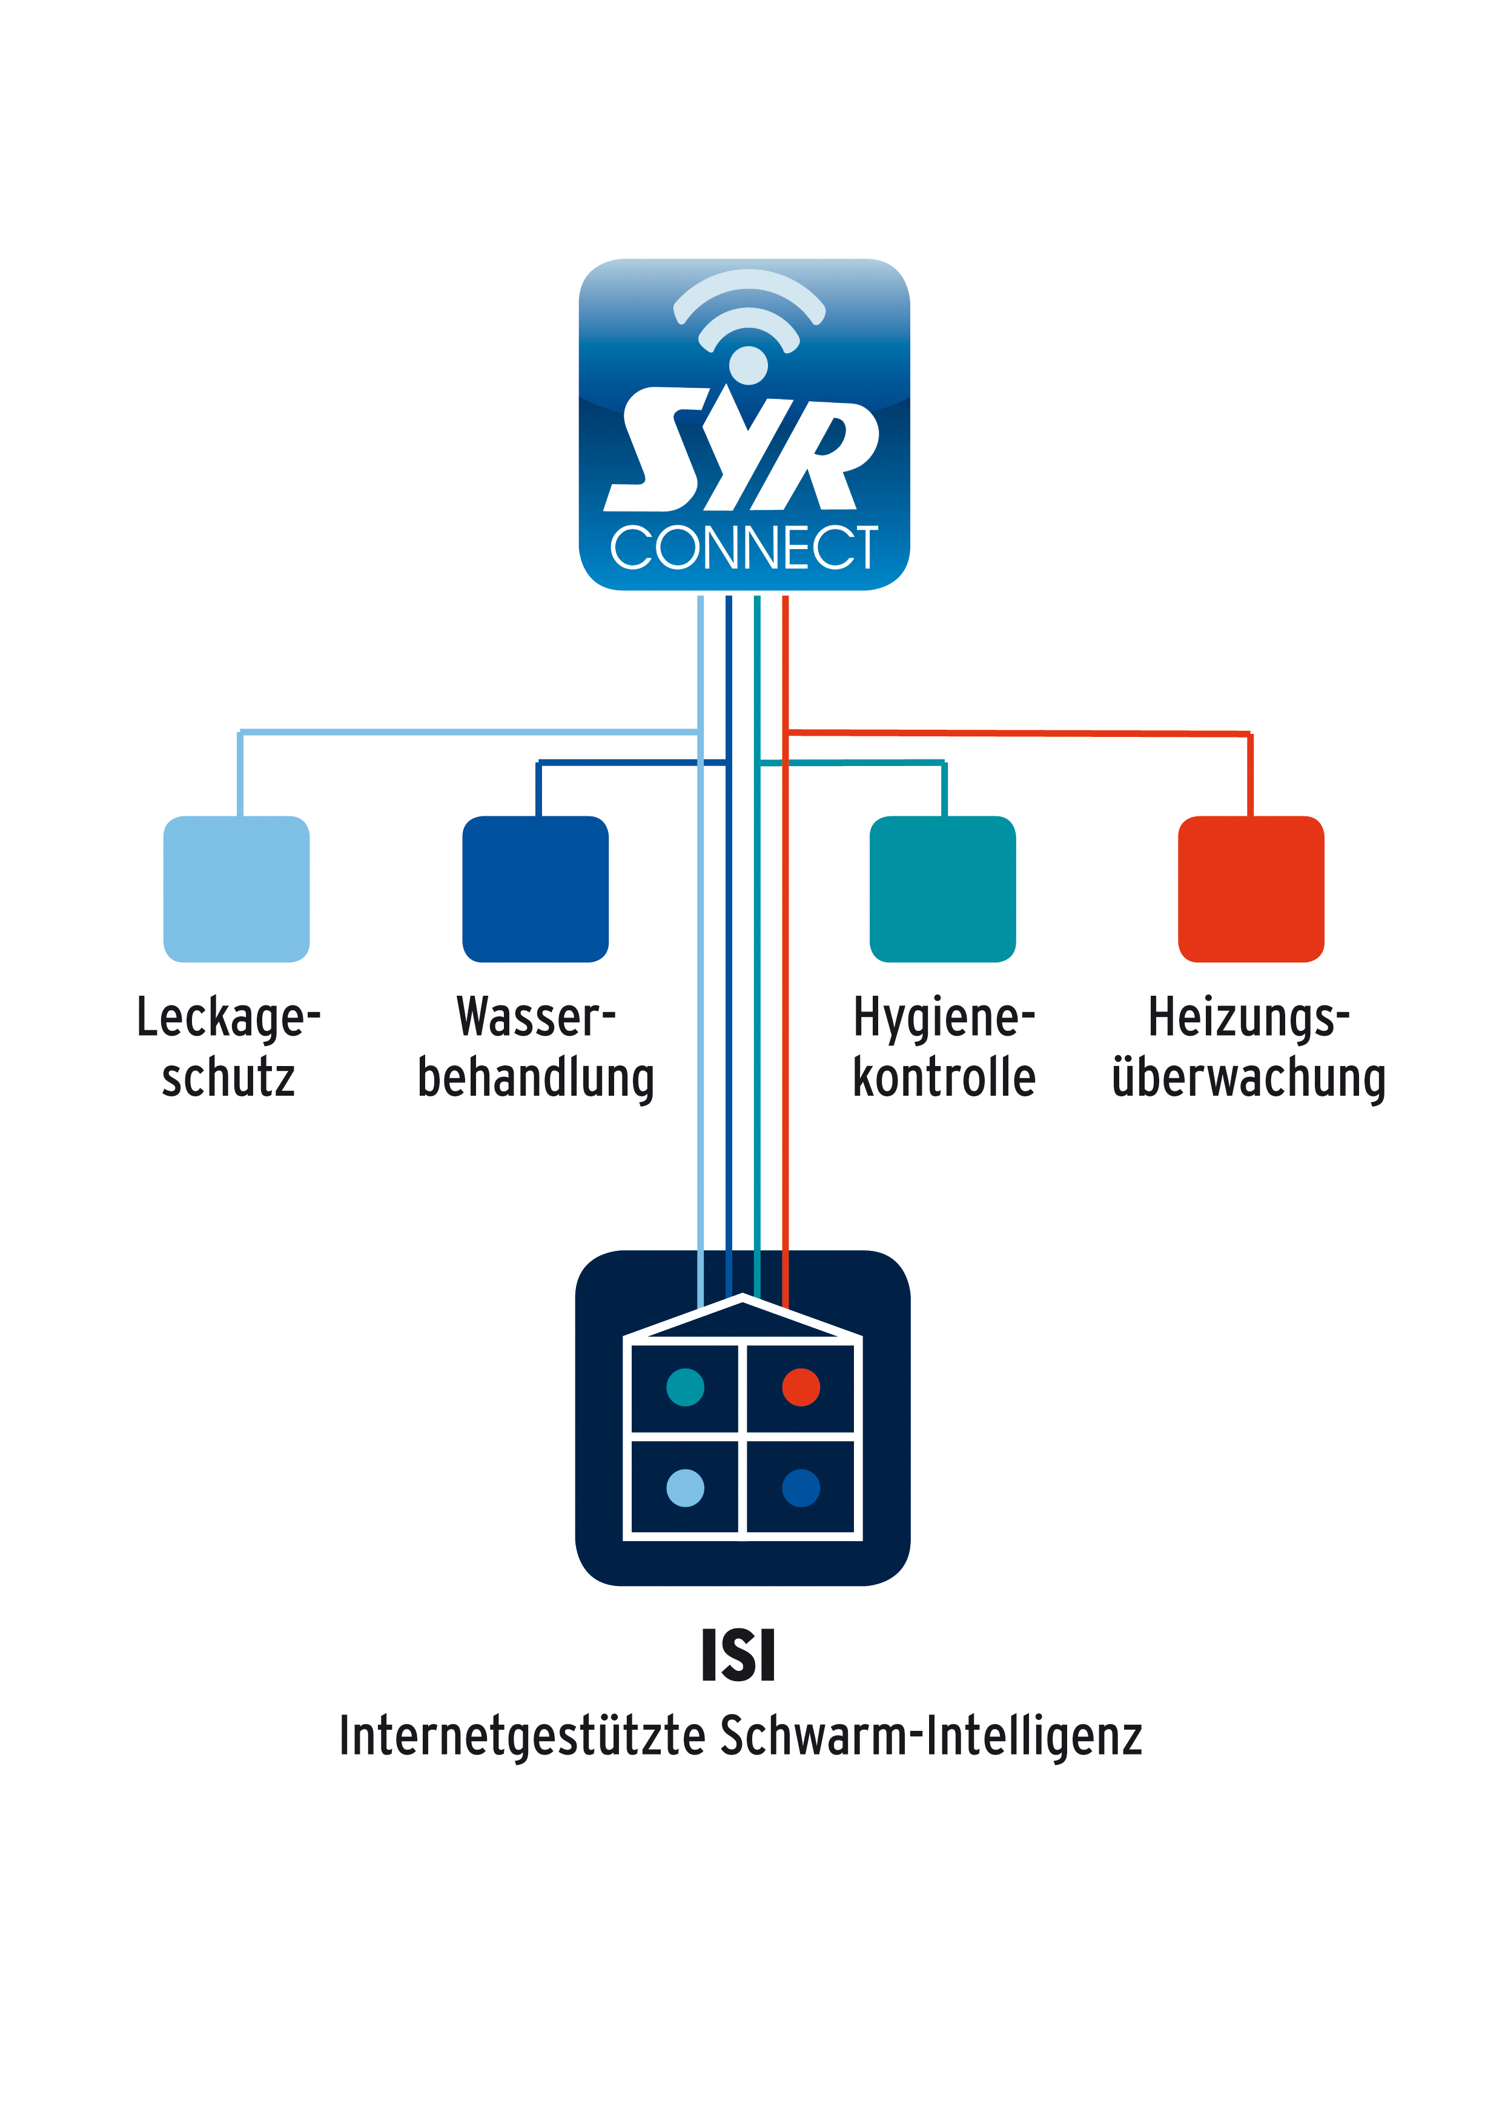  Leak protection  Water treatment  Hygiene monitoring  Heating monitoring  ISI  Internet-supported swarm intelligence | 
05: SYR Connect allows users to conveniently control their Safe-T Connect or ISI leak protection valves from outside the house. Other fields – and therefore valves – can also be operated and controlled with this technology.  Source: SYR Hans Sasserath & Co. KG | 06 The domestic water station PrimusCenter 2013 received the Red Dot Award for Product Design for its successful overall concept.  Source: Honeywell GmbH – Haustechnik
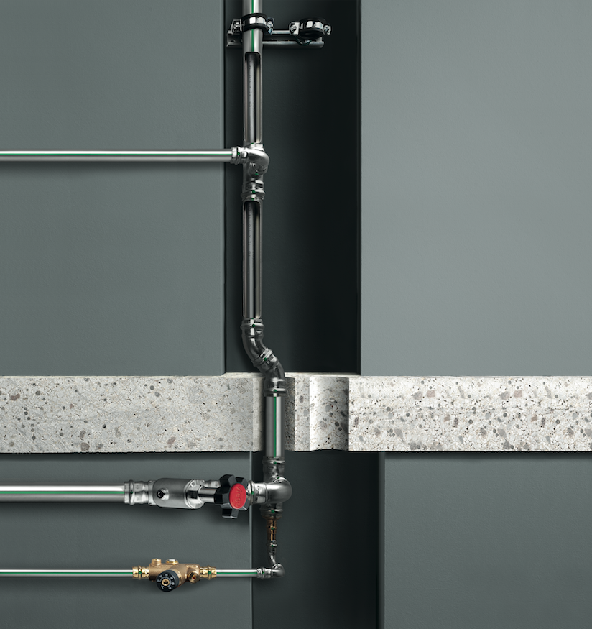 | Press contact:  Blue Responsibility  c/o Public Affairs PR Agentur GmbH  Kirsten Vogt / Antje Frommfeld  Kamekestr. 21, 50672 Cologne, Germany  Tel.: +49 221 951441 -911/-913  kirsten.vogt@public-affairs.de /  antje.frommfeld@public-affairs.de
07: With over 400 litres of storage and/or a pipe capacity of more than three litres between the outlet of the hot water storage tank and the most remote tap, parallel or internal circulation systems prevent stagnation.

Source: Viega GmbH & Co. KG

